Manufacturer’s CLS Product Information
This form is available in a Microsoft Word version from the ENA’s website.
G100/2 - Form B - Compliance Verification Report for Customer Export or Import Limitation Schemes
This form shall be used by the Manufacturer to demonstrate and declare compliance with the requirements of EREC G100. The form can be used in a variety of ways as detailed below:
1. For Fully Type Tested status
The Manufacturer can use this form to obtain Fully Type Tested status for a CLS by registering this completed form with the Energy Networks Association (ENA) Type Test Register.
2. To obtain Type Tested status for a product
The Manufacturer can use this form to obtain Type Tested status for one or more Components which are used in a CLS by registering this form with the relevant parts completed with the Energy Networks Association (ENA) Type Test Register.
3. One-off Installation
The Installer can use this form to confirm that the CLS has been tested to satisfy the requirements of this EREC G100. This form shall be submitted to the DNO before commissioning.
A combination of (2) and (3) can be used as required, together with Form C where compliance of the CLS is to be demonstrated on site.
Note:
If the CLS is Fully Type Tested and registered with the Energy Networks Association (ENA) Type Test Register, Form C shall include the Manufacturer’s reference number (the Type Test Register system reference), and this form does not need to be submitted.
Where the CLS is not registered with the ENA Type Test Register or is not Fully Type Tested this form (all or in parts as applicable) shall be completed and provided to the DNO, to confirm that the CLS has been tested to satisfy all or part of the requirements of this EREC G100.
CLS Designation
Manufacturer name |  | J.P.Baxter and Company LTD
Address |  | Moss House Farm  Manchester Road – Longhill  Buxton, Derbyshire SK17 6SS
Tel | +44(0)7880 747941 | Web site | www.jpbaxterandcompany.co.uk
E:mail | johnb@jpbaxterandcompany.co.uk
Installer’s name | J.P.Baxter and Company LTD
Address | Moss House Farm  Manchester Road – Longhill  Buxton, Derbyshire SK17 6SS
Tel | +44(0)7880 747941 | Web site | www.jpbaxterandcompany.co.uk
E:mail | johnb@jpbaxterandcompany.co.uk

Export/Import capabilities
Export | Y / N | Import | Y / N
Description of Operation
EREC G100 section 4.2 requires a description of the CLS, and schematic diagram, to be provided to the Customer. Please provide that description and the diagram here.
The CLS has a metering (2 qty if HV) that monitors the Connection Point and controls the Devices current output to ensure that the MEL is not breached. Should the CLS enter into State 2 control then Excursion timers are started in the CLS PLC and if any of these Excursion criteria are exceeded then the CLS will enter into State 3 lock out and requires user intervention to reset, reset can only be done after 4-hours. The JPB&Co. CLS is not designed for domestic installations.
Control of State 1: CLS PLC monitors the current flow on the Connection Point and issues this signal to the Device(s) for them to profile the generation to suit the site load, or the CLS will actively profile the Device(s) generation using PID loop algorithms.
State 2 control will still keep the modulation routine active and should the MEL excursion last longer than 15-seconds then the Excursion timers will start and be recorded by the PLC in non-volatile memory. To avoid State 3 lockouts the CLS PLC will stop the generation using hardwired signals prior to entering into a lockout state.
State 3 lockout is triggered should an Excursion timer expire and results in a hardwired connection to the Device going open circuit (fail safe for wire break, loss of supply to the CLS or loss of DC supply to the PLC), which will result in the Device ceasing generation immediately.
CLS connected to HV supply. Typical example. This being the conceptual representation as per EREC G100 §4.1.
Single Line Diagrams will be provided on a site by site basis based on the G99 SLD.
Communications Media
Document the provisions made for the use of various communication media, and both the inherent characteristics and the design steps made to ensure security and reliability.
The communication between the Components of the CLS are as follows:
CT and VT to meter(s): Hardwired and monitored, CT wire break or open spilt CT will result in communications loss after 14.5 seconds. Voltage sense will result in communications failure if the voltage is less than 180volts L-L or L-N (HV or LV) for 14.5 seconds.
Meter(s) to CLS / Reverse Power Relay PLC. The medium is copper wire, fibre optic or radio link depending on site geography. The protocol is RS485 Modbus. Communications is monitored by the CLS / RPR PLC and should the seconds clock on the meter(s) move too far from the synchronised clock on the CLS / RPR PLCs then communications failure will be instigated. The time to enter lockout from communications failure is between 10-14 seconds.
The CLS PLC to Device(s). The medium is copper wire or via fibre optic. The signal is mA or Modbus Word. This control is for State 1 and State 2 control. Should this signal fail then the Device will reduce its output to zero or its operational minimum. The State 3 lockout signal is a closed to allow generation open circuit to inhibit generation. Wire break or loss of communications results in no generation at the Device(s).
Various system checks are made between the Components of the CLS so that if a Component becomes disconnected from the rest of the CLS then it will inhibit generation for that section or the entire CLS. This is done using heartbeats that if lost for 14 seconds, will result in the CLS moving into State 3.
Cyber Security
Confirm that the Manufacturer or Installer of the CLS has provided a statement describing how the CLS has been designed to comply with cyber security requirements, as detailed in section 4.7.
The CLS PLC and RPR PLC can operate as a stand-alone system without interaction with the Internet or other wider networks. Where the Modbus function is required or local Webserver access is desirable, then this is implemented via Local Area Networks only and they should not be exposed to wider networks i.e. physically isolated from the Internet.
It is preferable that the network be isolated from the outside world, either by physical connection (air gap), or by suitable firewall, firewall as a last alternative. Due consideration should also be given for possible threats introduced by memory storage hardware crossing any physical gap or firewall i.e. persons using memory sticks on hardware on the same network as the PLCs.
Note that the Siemens PLCs will only communicate on Modbus if the client has the IP address that has been pre-programmed in the PLC (this is adjustable at commissioning). What this means is that the IP address of the client must match the IP address that the PLC expects to see in the header of the IP packet, furthermore the PLC will only send data to that pre-programmed IP address. This is very important, as communications will not work if the IP addresses do not match. The main areas of hardware that may be affected are typically those that can be connected to a LAN or a WAN network.
Extracted from Siemens (PLC OEM) and adjusted for this document: In order to protect the CLS CP from possible cyber threats, it is necessary to implement and continuously maintain a holistic, up to date and continuously reviewed security concept. The logic controller only forms part of this concept and it is down to the end user to ensure that sufficient protection is maintained from such threats i.e. don’t interfere with the PLC’s networks or connect anything to the PLC’s network without consulting the person responsible for the generating Device. Keep the panel secure from unauthorised personnel, persons gaining direct access to the CLS CP can cause malicious intent by physical damage or by disconnecting network Components or adding malicious Components, this falls out of the remit of this document as local access by persons with malicious intent can do harm and the CLS provider cannot post a sentinel to secure the panel 24/7, this would be down to the end user to ensure that the Device and the Components that form the CLS are kept secure from restricted access and are not interfered with by site personnel or other agents.
Information about ‘Air-gapped’ networks.
Air gaps have been a common security measure in the critical infrastructure sector, where a cyber-attack can disrupt or halt major operations. The systems that deploy gapping normally include:
- Military computer systems and networks
- Governmental computer systems and networks
- Financial computer systems and networks
- Industrial control systems
- Nuclear power plants
- Aviation computers
- Medical equipment.

This isn’t to say that an air-gapped network is completely safe, the obvious example being the Stuxnet incident that occurred in Iran, which was propagated using USB storage drives carried across the air-gap. For our network there is no USB connection and there is no permanent personal computer on the network and on a day to day basis there is no reason for a user to access the network or connect to the network as user conveyance is via the HMI, so this somewhat mitigates the air-gap breach scenario.
General basic network security concepts adopted in this CLS:
- PLC password protected
- Webserver password protected
- Acuvim II meter password protected, albeit only on a serial connection, so unlikely to be an attack vector
- Modbus data from the Acuvim II and PLC is set as read only, non-writable, serial connection
- LAN network is isolated by air-gap (no physical connection to a wider network / Internet).
The CLS provider / Device provider / Installer will undertake a study with the site to determine the best cyber security approach to be undertaken. In its simplest, should the client wish to receive Modbus data from the CLS, then we could convert this from TCP/IP to serial (all Modbus data is read only) and this would then limit the extent that the communications can propagate and the type of systems that can gain access to this type of network (serial). A serial network embedded inside a building would be considerably safe from a cyber-attack from an external malicious agent.
We believe that due to the above and nature of the stand-alone system, that this meets the recommendations for consideration as set out in G100/2-2
- ENA Engineering Recommendation G99 Issue 1 Amendment 8 2021
- ETSI EN 303 645;
- PAS 1879 “Energy smart appliances – Demand side response operation – Code of practice”;
That said, no single set of standards is sufficient to cover cyber security and on-going threats from malicious agents. We prefer an air-gapped system over all others due to the malicious agent needing to gain physical access to the CLS and have sufficient knowledge to “hack” the Components of the CLS, but if the intention is to stop the Device(s), then simply turning the power off to the CLS would be sufficient due to the fail-safe nature of the CLS.
Where the CLS is connected to a wider network then we would need to understand the routers, firewall policies, what ports are open etc. and would insist that the system be maintained with the required firmware patches so that known vulnerabilities are patched. Each install will be dealt with on a site by site basis, but at present the air-gap approach has been suffice for the CLS scheme.
Power Quality Requirements
Where the CLS includes the power electronics that controls generation or loads (as opposed to the power electronics being included in Devices that are subject to their own power quality compliance requirements) please submit the harmonic and disturbance information here as required by EREC G5 and EREC P28.
Not applicable. All Power Quality electronics are in the Device(s).

Fail Safe
CLS internal failure: please submit here the description of the internal Fail Safe design and operation. Please also document how it has been demonstrated, including the non-volatile recording of times and numbers of state 2 operations, and confirm the overall response of the CLS to this internal failure.

CLS System, Component fail safe and general alarms
To afford fail safe protection and G100 protection the following mechanisms are continuously monitored and assessed:

Communication between the G100 Meters (CLS Meter and Reverse Power Relay Meter)
The data is communicated as a Modbus signal and the PLC monitors the change of the clock in the Acuvim II meter, and on initial CLS PLC power on synchronises its seconds count with the Acuvim II’s seconds’ count. After this there should not be more than a 1 second difference between the two timers. Should the timers differ by too much then a communication alarm is issued. The difference allowed is -3 to +4 with this difference needing to be present for 8 seconds and therefore determining the communications loss within 15-seconds as per EREC G100. The timer is re-synchronised every 60 seconds so that the clocks do not start to drift over time causing nuisance false trips. Should a communications loss occur then the PLC timer will continue to count where-as the Acuvim II’s count will have stopped, once the difference between the two counts is more than 4 for a period 8 seconds then the communications alarm will activate.
There is also an additional monitor that looks at the Acuvim II’s serial number, it should always be more than 0, if communications are lost, after a brief period ~6-7seconds, the register will default to 0 and this will trigger a loss of communications state (State 3). It should be noted that the 0 value only gets written when connected directly on Modbus TCP/IP, if via a gateway device then the gateway device may continue to send the last value that it received from the meter. This has been the case for the tGW-715 gateway device that we tested and was also the case for a Phoenix device that we tested. In reality only one communications mechanism is needed..
As per EREC G100/2 §4.5.2.2 the communications loss is auto resetting, albeit other conditions may have triggered due to the failure.
Alarm:
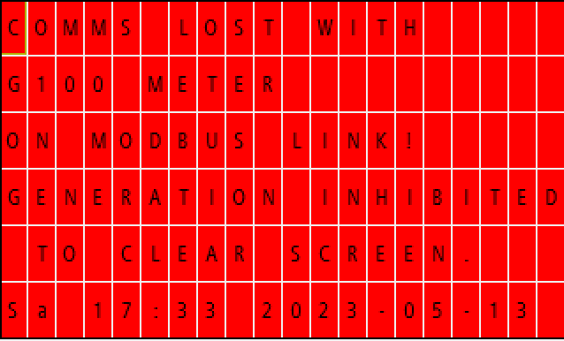
Note the alarm is self-resetting, but the screen latches to show what caused the error, press ‘OK’ to clear the latched screen.
Possible causes are wire break, wire short, meter power off or malfunction, loose connection or faulty RJ45 connector at meter or CLS PLC, faulty switch, faulty gateway device.
It may take up to 120-seconds to clear the loss of communications alarm once it is restored.
The CLS PLC and the Reverse Power PLC both monitor for loss of communications and will instigate a State 3 if a loss is detected.

Communications failure between the CLS PLC and the RPR PLC
The two PLCs poll each other’s heartbeat that toggles a bit every 0.5 seconds. This bit acts on an edge triggered input that maintains an off delay timer (set at 14-seconds) from switching off. Should communications be lost then the heart beat will not keep the off delay timer from timing out and after 14 seconds the CLS will enter into a State 3. The system will reset once communications are back, however the screens will continue to show a fault until the ‘OK’ button is pressed.
Alarm screens, left CLS PLC, right RPR PLC alarm:
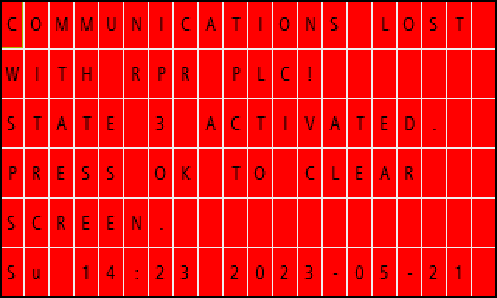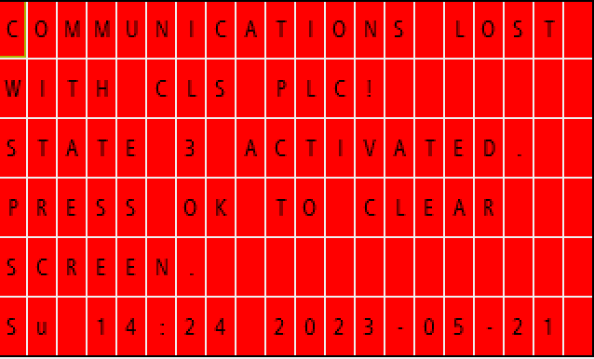

Communications failure for current transformer monitoring (CT failure)
The current transformers are monitored for loss of current flow down to the mA level. This is monitored on the Modbus connection to the PLC from the Acuvim II and has a Modbus exponent register that allows for 0 to 32767 monitoring with an exponent of /1000, /100/, /10, x10, x100. The PLC expects to see more than 0mA as it is highly unlikely that there will never be current flow across a phase unless there is a CT failure (open circuit) or the supply to that phase is lost, which would be an abnormal situation and will result in State 3 operation. Should the supply be lost to this phase then the voltage communications loss alarm for that phase will also be present.
The CLS PLC and the Reverse Power PLC both monitor for CT failure and will instigate a State 3 if a failure is detected.
As per EREC G100/2 §4.5.2.2 the communications loss is auto resetting, albeit other conditions may have triggered due to the failure.
Alarm (also available for L2 and L3).
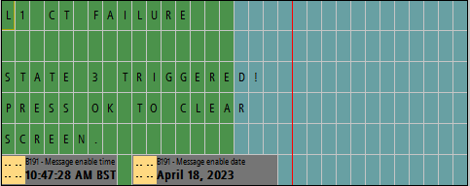
Note the alarm is self-resetting, but the screen latches to show what caused the error, press ‘OK’ to clear the latched screen.
Possible causes are wire break, loss of communication with Acuvim II meter, meter power off or malfunction, CT failure or open circuit / loose wire, phase that the CT is monitoring is open circuit.

Loss of voltage sense communications failure
The Reverse Power Relay uses the voltage sense to determine the kWe in concert with the CTs. To avoid unduly burdening the voltage transformers the panel may be supplied by a local source, this being the power to keep the relay powered and not the voltage sense for kWe determination mechanism. To remain compliant with certain standards, i.e. 60204-1 / LVD, and OEM manufacturer's installation instructions, there are slow blow fuses on the voltage sense and installed door interlocked isolators to restrict access to the “layman”. From this it would be possible to isolate the voltage sense supply or a fuse or VT could fail and you could lose one of the phases for voltage sense, the relay then interprets for that phase or all phases lost the following:
P = IV or 20*0 = 0. (20amps, 0volts [all phase] as an example for this illustration).
As anything multiplied by 0 results in 0 then the relay will return a 0kWe value regardless of current flow and therefore the Reverse Power Relay will be compromised.
Loss of a VT or fuse on the voltage sense will result in loss of power sense on that phase or any number of phases that have lost their respective voltage sense. This is the case regardless of the CT direction as a loss of phase would give a potential 1/3 under read of the actual power, which could then result in breaching the agreed G100 trip set point, especially on export.
To mitigate this the CLS monitors the phase to neutral voltage and phase to phase voltages of all phases. Should the value fall below 180 volts for 14-seconds (<15-seconds as per that allowed in EREC G100/2), then the CLS will move into a State 3 condition. This ‘180 volts’ value is out of the way of the G99 relay and will work for both LV and HV (HV ratio will have already been applied at the meter so will be in the kilo range) as it is to purely show a loss of voltage for that phase.
The voltage loss mechanism is not part of G99 and is not there to afford this protection, the G99 should be by separate Component that is not in the scope of this document.
The CLS PLC and the Reverse Power PLC both monitor for loss of voltage sense and will instigate a State 3 if a voltage sense is detected.
As per EREC G100/2 §4.5.2.2 the communications loss is auto resetting, albeit other conditions may have triggered due to the failure.
Alarm.
Alarm screens also exist for L2 and L2.
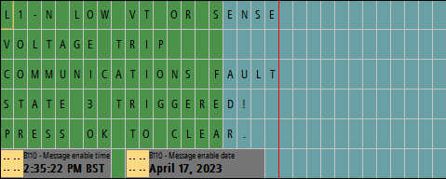
Alarm screens also exist for L2-L3 and L3-L1.
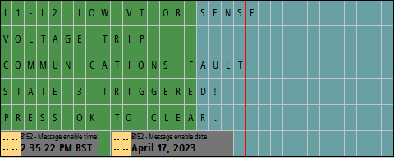
Note the alarm is self-resetting, but the screen latches to show what caused the error, press ‘OK’ to clear the latched screen.
Possible causes are wire break, loss of communication with Acuvim II meter, meter power off or malfunction, VT failure or open circuit / loose wire, phase that the VT is monitoring is open circuit, power loss to that phase from internal or external influence (DNO supply failure), blown sense fuse, faulty Acuvim II meter.

Communication loss between CLS and Device
The communications between the CLS and the Device for the main ‘G100 trip’ is a maintained normally open, energised closed for healthy that feeds back a signal to the Device to allow it to generate. Should the wire break, there be a malfunction or power loss at the CLS then the circuit will become open, and the Device will stop generation.
For State 1 and 2 controls the CLS will use analogue (via either 4-20mA or Modbus) to indicate the load or use digital controls to taper generation in a stepped manner as per the table below.
The table below is the Power Reduction Control as used on Solar Edge solar inverters and is an example of a generation reduction control for State 1 and 2 control that does not afford itself to analogue control due to the limitation of the inverter.
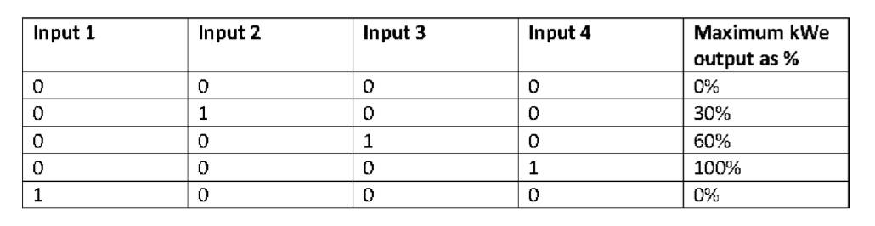
In all events an open circuit of the analogue or taper control digital signals will result in the generation either stopping or moving to its lowest output.
The CLS CP does not monitor upstream of the system and the alarm for loss of generation will be shown on the Device.

Reverse power trip from Reverse Power Relay (HV install)
The G100 Metering has two Acuvim II meters, one is for CLS State 1,2,3 control and the other is dedicated for the Reverse Power Relay function. This communicates back to the Reverse Power PLC via a dedicated serial line and gateway that is independent of the CLS PLC’s system.
The Reverse Power Relay (RPR) PLC monitors the communications, voltage, CT failure, in the same way as the CLS PLC, so has more functionality than a standard Reverse Power Relay, in reality it has the same functionality of the CLS PLC so sits in duplicate as a redundant system to trip generation should the CLS PLC fail.
This alarm is normally open, closed (maintained) when healthy, so therefore a wire break or loss of supply to the G100 Metering or RPR PLC will result in an open circuit, as would a wire break, all these events will move the CLS to Stage 3.
The G100 Metering RPR Meter independently monitors the kWe at the Connection Point and if the kWe breaches the internal set point of the 'Reverse Power Relay' for the time as per EREC G100/2 §4.3.2, then this alarm is issued (below), and the generation is stopped immediately and the CLS moves to State 3.
A general note on this setting is that it should be set that the CLS PLC has the main control and this is the last line of defence. This trip should not be normally invoked as the CLS PLC’s reverse power trip setting should be set to activate before this trip.
From a settings point of view the trip value can be derived by using the stated MEL ampere rating and applying the following maths:
MEL[amps] * nominal volts L-L * 1.732 * 0.9[allowing some scope for PF] = P (reverser power trip setting)
Example: The DNO has issued a MEL of 25 amps of export on a 11,000volts connected installation. We need to determine a reverse power trip setting and the maths would be:
25 * 11000 * 1.732 * 0.9 = 428.7kWe. Therefore the trip setting is 428kWe in the relay. The time delay could be as per EREC G100 §4.3.2, but the DNO may wish for this trip to be instant as per EREC G100 §4.5.3.1. The EREC G100/2-2 is not very clear on this one as you are allowed to have excursions above the MEL but are not allowed for the ‘Reverse Power Relay’. We have interpreted G100 that G100 EREC §4.5.3.1 is written for non-failsafe CLS and the statement for HV connected installations would allow a timer to be present above the MEL to allow for State 2 excursions otherwise what is the point of G100 EREC §4.3.2.
Additionally G100 EREC §4.5.3.1 does not provide guidance, scope or any more information on the setting of the Reverse Power Relay and therefore the maths provided above, especially the PF component will be based on a discussion between the DNO and the nominated G100 CLS test engineer.
It is also possible to set the RPR PLC to trip on average current, as well as kWe.
Alarm on RPR PLC current (amps) trip left, kWe set point breached trip right, trip that is shown on the CLS HMI bottom.
It is required that the RPR PLC’s integral HMI be viewed for the specific alarm, and this is within the panel.
The trip can be reset by pressing F2 on the mains door mounted HMI.
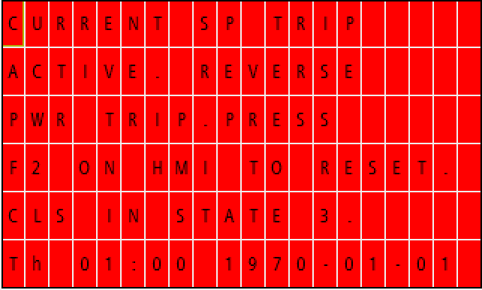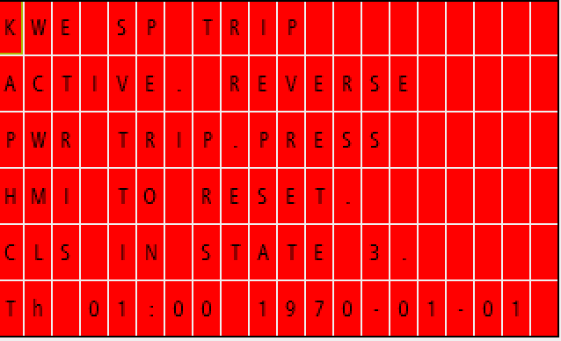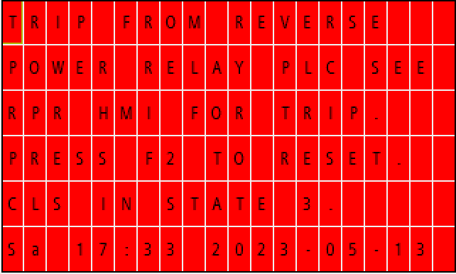

Excursion lockouts
During State 1 control, loss of modulation or curtailment of the generation to maintain the current below the desired MEL resulting in an excursion that does not breach the excursion time as per EREC G100/2 §4.3.2 but is longer in duration than 15-seconds is counted as an excursion. Excursions are dealt with in EREC G100/2 §4.5.1.3, and are summarised below:
Excursion criteria:
- A single excursion into State 2 operation that persists for more than 1 minute (or 3 minutes as allowed in EREC G100/2 §4.3.2)
- There are more than three excursions (each of more than 15-seconds and less than 1 minute (or 3 minutes as allowed in EREC G100/2 §4.3.2) into State 2 operation in any 24-hour period
- The time between any two consecutive excursions into State 2 operation of greater than 15-seconds in 10 minutes or less (measured from the time of re-entry into State 1 operation from State 2 operation following the first excursion), or
- For installations where the maximum excursion period is 3 minutes (as allowed in §4.3.2) the total time in State 2 operation in any 24 hour period, but neglecting any excursion of 15-seconds or less, exceeds 8 minutes.
Note a State 3 condition that is caused by an excursion causes the CLS PLC to lock the reset button for 4-hours. This is detailed in §4.5.2.1. Communications failures are not part of this process and will reset or require resetting once they have entered the healthy condition.
For excursion criteria 1 the CLS PLC trips all the Devices if the threshold setting is breached for the time allowed, normally based on EREC G100/2 §4.3.2 time allowance for criteria 1. (60 / 180 seconds depending on the Device).
This is a State 3 trip and requires a user reset to clear.
The time during the excursion above the initial 15-seconds will be recorded for excursion criteria 2,3,4. Should these criteria be breached then the CLS will enter State 3 and will require user intervention.
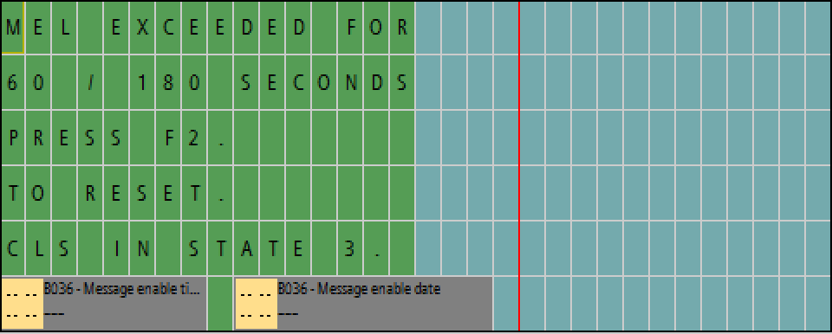
.
For excursion criteria 2 the CLS PLC monitors each excursion in a continuously rolling 24hr window and should there be more than 3 excursions i.e. 4, then the CLS will move to State 3 excursion lockout and the alarm screen below will show.
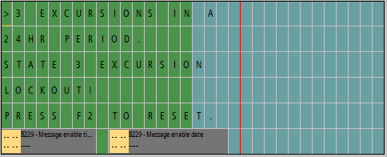
For excursion criteria 3 the CLS PLC monitors for an excursion into State 2 and should this occur it starts a 10-minute timer after the excursion has ended and should there be another excursion within this 10-minute window then the CLS will move to State 3 excursion lockout and the alarm screen below will show.
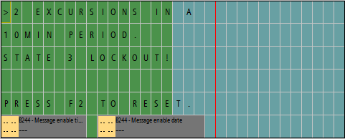
For excursion criteria 4 the CLS PLC monitors each excursion in a continuously rolling 24hr window and should there be more than 480-seconds (8-minutes) within one of the rolling 24hr windows then the CLS will move to State 3 excursion lockout and the alarm screen below will show.
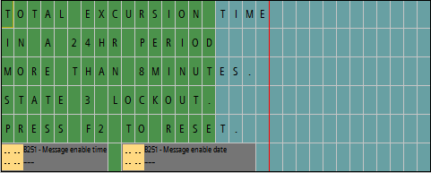
As per EREC G100/2 §4.5.1.3 all excursion timers, lock out alarms are stored in non-volatile memory to ensure that the states are maintained in the event of a CLS PLC loss of supply and subsequent restoration of supply.

4-hour reset inhibit timer
As per EREC G100/2 §4.5.2.1 it is not possible in a non-domestic installation to reset a State 3 latch without waiting 4 hours. The PLC starts a timer once the State 3 is entered and a warning / indication screen is issued on the HMI as per below, this details that the reset inhibit is active and shows the amount of time remaining that the user will need to wait.
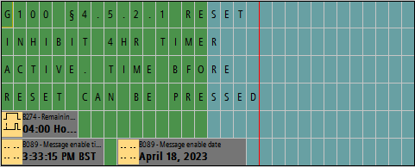
The CLS as described in this document is not intended for domestic installations.
All Excursion timed data and latched state are stored in retentive memory as per the Siemens PLC for storing memory items into non-volatile storage so that the latch or timed criteria is remembered should the PLC / CLS be power cycled.

Communication and power supply failures between Components and Devices. Please document here compliance with EREC G100 section 5.5.
Component/Device number/description | Communication failure test | Power supply failure test
CLS Meter | State 3 <15 seconds | State 3 <15 seconds
RPR Meter | State 3 <15 seconds | State 3 <15 seconds
CLS PLC | State 3 <15 seconds | State 3 <1 seconds
RPR PLC | State 3 <1 seconds | State 3 <15 seconds
5-port switch CLS Component | State 3 <15 seconds | State 3 <15 seconds
24volt DC control supply | State 3 <1 seconds | State 3 <1 seconds
Serial to TCP gateway devices | State 3 <15 seconds | State 3 <15 seconds

Operational Tests
In accordance with EREC G100 section 5.6 undertake the tests A and B to confirm correct operation in state 1 and state 2, that transition into state 3 occurs as required, and that behaviour in state 3 is also as required.
Test A
Nominal Export Limit (for type tests this will be at maximum, minimum and one intermediate setting) in Amp: |  |  |  |  |  | 22
Nominal Import Limit (for type tests this will be at maximum, minimum and one intermediate setting) in Amp: |  |  |  |  |  | N/A
No | Starting level | Step value | CLS registers change in level? | CLS and/or Component and/or Device initiates correct response of ≥ 5%? | Duration of step in test | Correct state 1/  state 2 operation
1 | 20.9 | 23.1 | yes | yes | 58s | 1 > 2 > 1
2 | 20.9 | 24.2 | yes | yes | 58s | 1 > 2 > 1
3 | 20.9 | 26.4 | yes | yes | 58s | 1 > 2 > 1
4 | N/A | N/A | N/A | N/A | N/A | N/A
5 | N/A | N/A | N/A | N/A | N/A | N/A
6 | N/A | N/A | N/A | N/A | N/A | N/A
Test B
Nominal Export Limit: |  |  |  |  |  | 22
Nominal Import Limit |  |  |  |  |  | N/A
No | Starting level | Step value | CLS registers change in level? | CLS and/or Component and/or Device initiates correct response of ≥ 5%? | Duration of step in test | Correct state 3 operation
7 | 20.9 | 23.1 | yes | yes | 62s** tripped in 60secs. | 1>2>3
8 | N/A | N/A | N/A | N/A | N/A | N/A
Test A and B (tests above) to be filled in at CLS commissioning. Current (amps) values from 400kW @11kV unity PF.

State 3 Reset
These tests are to demonstrate compliance with section EREC G100 4.5.2.
Please document how the reset from state 3 to state 1 has been demonstrated. Please include how the reset is achieved.
Please confirm that for CLSs to be installed in Domestic installations three (3) resets causes lockout or that for non-domestic installations lockout can only be reset after four hours. Please explain how lockout is reset.
If State 3 is entered, then the PLC will lockout and reset will not be possible until a 4-hour timer has elapsed.
Process:
State 3 lockout > Investigation carried out to determine State 3 cause > Competent person resets CLS using HMI after 4-hr timer has expired > CLS returns to State 1, generation at Device(s) allowed to resume. No remote reset facility available.
Reset is achieved by pressing the function buttons on the HMI as per the instructions on the HMI.

